Too Square

Game Design Doc

***‘For when you are feeling bored of being edgy’*** - you

Table of Contents and Team Member Listing

| Table of Contents  [1 Game Overview](https://n-xovwktmtjsnaxyc2mwes2xu7pohqedmdm6zjw5q-2lu-script.googleusercontent.com/userCodeAppPanel)  [2 High Concept](https://n-xovwktmtjsnaxyc2mwes2xu7pohqedmdm6zjw5q-2lu-script.googleusercontent.com/userCodeAppPanel) / Genre  [3 Unique Selling Points](https://n-xovwktmtjsnaxyc2mwes2xu7pohqedmdm6zjw5q-2lu-script.googleusercontent.com/userCodeAppPanel)  [4 Platform Minimum Requirements](https://n-xovwktmtjsnaxyc2mwes2xu7pohqedmdm6zjw5q-2lu-script.googleusercontent.com/userCodeAppPanel)  [5 Competitors / Similar Titles](https://n-xovwktmtjsnaxyc2mwes2xu7pohqedmdm6zjw5q-2lu-script.googleusercontent.com/userCodeAppPanel)  [6 Synopsis](https://n-xovwktmtjsnaxyc2mwes2xu7pohqedmdm6zjw5q-2lu-script.googleusercontent.com/userCodeAppPanel)  [7 Game Objectives](https://n-xovwktmtjsnaxyc2mwes2xu7pohqedmdm6zjw5q-2lu-script.googleusercontent.com/userCodeAppPanel)  [8 Game Rules](https://n-xovwktmtjsnaxyc2mwes2xu7pohqedmdm6zjw5q-2lu-script.googleusercontent.com/userCodeAppPanel)  [9 Game Structure](https://n-xovwktmtjsnaxyc2mwes2xu7pohqedmdm6zjw5q-2lu-script.googleusercontent.com/userCodeAppPanel)  [10 Game Play](https://n-xovwktmtjsnaxyc2mwes2xu7pohqedmdm6zjw5q-2lu-script.googleusercontent.com/userCodeAppPanel)  [10.1 Game Controls](https://n-xovwktmtjsnaxyc2mwes2xu7pohqedmdm6zjw5q-2lu-script.googleusercontent.com/userCodeAppPanel)  [11 Player](https://n-xovwktmtjsnaxyc2mwes2xu7pohqedmdm6zjw5q-2lu-script.googleusercontent.com/userCodeAppPanel)  [12 Art](https://n-xovwktmtjsnaxyc2mwes2xu7pohqedmdm6zjw5q-2lu-script.googleusercontent.com/userCodeAppPanel)  [12.3 Audio](https://n-xovwktmtjsnaxyc2mwes2xu7pohqedmdm6zjw5q-2lu-script.googleusercontent.com/userCodeAppPanel)  [13 Procedurally Generated Content](https://n-xovwktmtjsnaxyc2mwes2xu7pohqedmdm6zjw5q-2lu-script.googleusercontent.com/userCodeAppPanel)  [13.1 Minimum Viable Product (MPV)](https://n-xovwktmtjsnaxyc2mwes2xu7pohqedmdm6zjw5q-2lu-script.googleusercontent.com/userCodeAppPanel)  [14 Wish List](https://n-xovwktmtjsnaxyc2mwes2xu7pohqedmdm6zjw5q-2lu-script.googleusercontent.com/userCodeAppPanel)  15 Bibliography   |  | | --- | | Game Development Team Members    PRODUCER  Nicolas Artates    PRODUCTION MANAGER  Nicolas Artates    PRODUCTION COORDINATOR  Nicolas Artates  GAME DESIGNERS  Nicolas Artates  SYSTEMS/IT COORDINATOR  Nicolas Artates  PROGRAMMERS  Nicolas Artates  TECHNICAL ARTISTS  Nicolas Artates  AUDIO ENGINEERS  Nicolas Artates  UX TESTERS  Nicolas Artates |
| --- | --- | --- |

|  |
| --- |

# 1 Game Overview

Title: Too Square

Platform: PC Standalone + iOS & Android

Genre: Sidescrolling Platformer

Rating: (10+) ESRB

Target: Casual gamer (aging from 12 - 30)

Release date: November, 2021

Publisher: Nicolas Artates

Description: This Game is based on the hit mobile games JetPack Joyride and Geometry Dash! This game is an infinite side scrolling platformer. The player, a cube with the ability to fly, as if propelled upward by a jetpack, collects coins and dodges enemies and obstacles until succumbing to an inevitable death.

# 2 High Concept / Genre The player, a square, will dodge other, less cool, shapes such as triangles and diamonds. The square hopes to collect circles to become more round himself.

# Genre: Side Scroller or Platformer

# 3 Unique Selling Points

A mix of geometry dash and jetpack joyride, this game will be free and a very accessible entry point into video games.

# 4 Platform Minimum Requirements

This game utilizes minimalistic graphics in order to provide a great user experience to all using minimal hardware requirements. Any relatively modern phone or computer should be able to run this game.

# 5 Competitors / Similar Titles

Jetpack Joyride and Geometry Dash

# 6 Synopsis

A square dreams of being more round, he braves a gauntlet of pointy shapes in order to collect circles to expand its roundness by utilizing his ability to hover.

# 7 Game Objectives

The square hopes to survive as long as possible in order to collect as many circles as it can before it eventually succumbs to the pointy shapes.

# 8 Game Rules

The square is on a track and bound by the ceiling and the floor. He must dodge incoming obstacles by floating around the screen in the y-axis. The more circles he collects the more round he gets! He wins by becoming a circle after attaining a certain amount of circles.

# 9 Game Structure

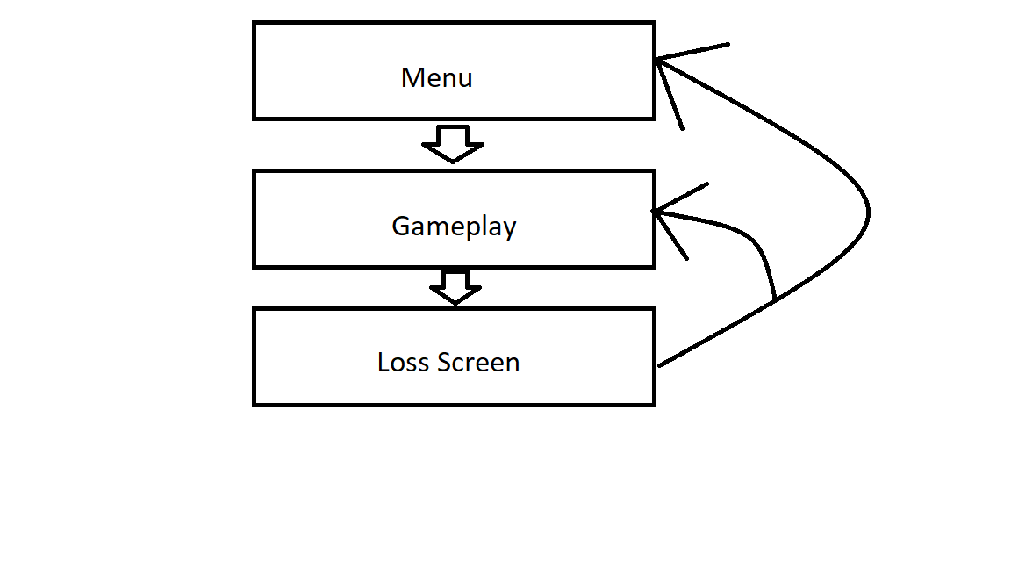

# 10 Game Play

The player floats up and is pulled down by gravity.

## 10.1 Game Controls

The player is controlled by very simple control scheme of a mouse click or button press on computer platforms and a simple screen touch on mobile platforms. On button/screen press the square goes up and on release gravity will pull it down.

### 

# 11 Players

## 11.1 Characters

Player is a square who gets more round as the game progresses.

## 11.2 Metrics

Player stats coming soon.

# 12 Art

Very simple minimalistic art focused primarily on simple shapes

# 13 Procedurally Generated Content(UNSURE)

## 13.1 Environment

## 13.2 Levels

## 13.3 Artificial Intelligence NPC

## 13.4 Visual Arts

## 13.5 Audio

## 13.6 Minimum Viable Product (MPV)

# 13 Wish List

Upgraded assets

Original background music

More animations

More varying sets for the player to navigate

## 14 Bibliography